Renju lesson on December 6, 2001
Hello everyone! Welcome to Online Renju Class. Today we will continue with d5, the variant that we prepared during last week. Note that 18-h12 is more optimal than 18-j10, because h12 forces black to play only one variant whereas j10 gives black more choices. How many of you did the analysis after last lesson? Nobody :(
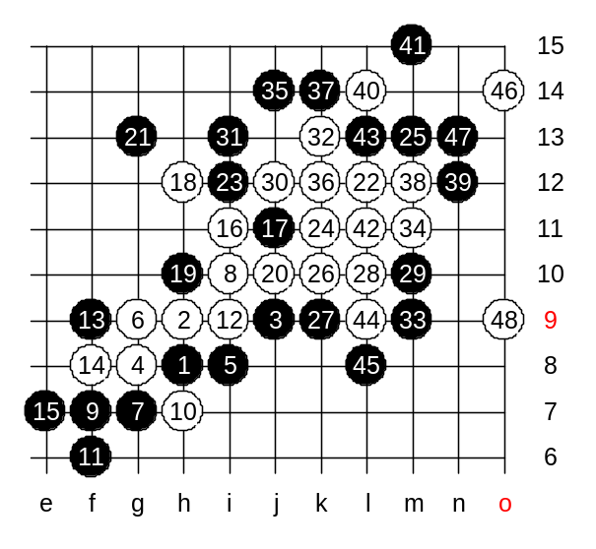
Which side should we block the white three after 30th move? (I just noticed, Volodymyr is here in lesson. It is the first time he joins our lesson. So glad to see him here. Welcome!)
We block form upper side. White takes the natural point.
Does white have VCF threat now? Yes, 4x4 trap. You are fast. How to block now?
Can black defend at all? We can smell overline coming. Also, white could have made a simple 4x3 in N-line. We chose 3x3.

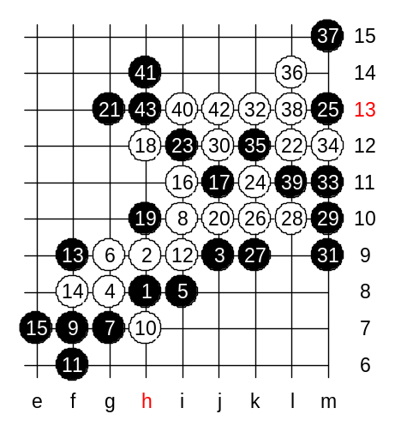
We use another 31st move now. Same 32nd – to k13. Does white have VCF now? It is an important question considering black activity on the left side. Yes, VCF.
Now, we use a logical defense. White seems to be close to success, but no win. There is no sequence.
Since white used its only way to attack, and still failed, so we can close this variant with the conclusion that white cannot do anything here.

Do you have any questions about this variant?

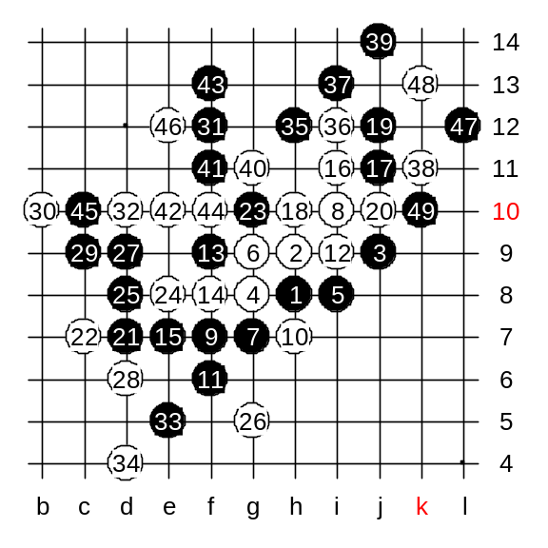
We try one more variant. 18-h10 is an interesting variant. White 36-i12 is forced. Otherwise black seems to win. The outcome of the variant is very chaotic.
It is hard to tell who has advantage here. Maybe black must choose some other moves instead of f11. The variant is all too complicated, We will never finish checking all moves here. It would take forever. So, until the sure conclusion is made, you can use the safe style that was shown last week.
The lesson is over now, thank you very much for coming! :)

